Design Thinking Evaluation Toolkit

Evaluating Student Progress in the Design Thinking Process

*ExtenDT2 Project 2025*

This Design Thinking Evaluation Toolkit helps educators evaluate student progress through the key stages of the design thinking process: **Empathise, Define, Ideate, Prototype, and Test**. The toolkit offers flexibility to be adapted to suit the needs of the students and educators. The rubrics can be amended and co-created, if relevant, with the input of students or fellow educators. This toolkit was codesigned with teachers from Ireland, Norway, Greece, Sweden and Belgium as part of the ExtenDT2 Project (<https://extendt2.eu/>).

Further instructions on using the Toolkit are provided on Page 2.

The toolkit consists of the following tools. Click on the list to navigate to each tool.

1. Progress Evaluation Checklist (Page 3)
2. Student Reflection Prompts (Page 4)
3. Collaboration Tracker and Teamwork Tracker (Page 5)
4. Visual Team Progress Map (Page 7)
5. Teacher Observation log (Page 8)
6. Rubric for Final Evaluation (Page 9)

***We hope this toolkit is helpful! If you want to provide any feedback and tell us how you used the toolkit, and if you found it useful/not useful, please contact us:***

* [Richard.harte@learnovatecentre.org](mailto:Richard.harte@learnovatecentre.org)
* [helena.ledermann@learnovatecentre.org](mailto:helena.ledermann@learnovatecentre.org)

Or complete a short anonymous survey at this link! <https://tinyurl.com/bd5cawak>

# How to Use this Toolkit

Dear Educator, this toolkit supports ongoing, formative assessment of students, while encouraging growth and learning throughout the Design Thinking process, with buy-in from students.

There are some important things to know before deploying these evaluation tools:

* **Modularity:** These tools can be used as a set or can be used individually, you decide!
* **Customisable:** Edit the tools as you see fit to suit your class. Change the language, ask different questions, create new rubrics.
* **Paper or Digital:** You can simply print off individual pages and use the paper version of the tool, you can also edit this document and print off your own version, or you can implement the tools digitally using applications such as Sheets, Excel, Trello, Padlet and/or Slido etc.
* **Student Buy-in:** Before using any of the tools, introduce the tools to students and explain their purpose. These tools are designed to help students learn, not to assess their aptitude. See if students are willing to customise the rubric to suit their language and understanding. Where appropriate conduct a pre-assessment to ascertain student prior understanding of Design Thinking topics.
* **Stage Based:** Use the checklist, tracker, and reflection prompts to evaluate progress and provide feedback at each stage of the Design Thinking process. Students may also dictate or log information on a digital platform (e.g. Padlet) in a manner that suits them. This increases pathways to success and responds to learner variability.
* **End of Process:** Review the rubric and observation log to assess individual and group outcomes. Provide feedback to students or ask students to provide feedback to you or to each other.
* **Use of GenAI:** Utilise ChatGPT or similar applications to brainstorm new ideas for rubrics, or to change the language in a rubric to suit different age groups or different subject areas. GenAI can also be used to provide summaries and insights of logs or observations. Be aware of your own school’s code of conduct around the use of AI!

# Progress Evaluation Checklist

This can be used by educators or can be edited to be used by students. Use this checklist at each stage to assess skill application and student understanding.

|  |  |  |  |
| --- | --- | --- | --- |
| **Design Thinking Stage** | **Target Skill Development** | **Key Questions** | **Progress Notes** |
| Empathise and Understand | Empathy, Listening, Observation | Did the student effectively listen to all parties involved? Did they demonstrate empathy by understanding the users’ needs and perspectives? |  |
| Define | Critical Thinking, Problem-Solving | Did the student define a clear, focused problem statement based on user needs? Does it align with insights from the Empathise stage? |  |
| Ideate | Creativity, Open-Mindedness | Did the student generate diverse and creative ideas? Were they open to exploring unconventional approaches? |  |
| Prototype | Problem-Solving, Iteration, Creativity | Did the student create tangible solutions that reflect their ideas? Did they iterate based on team or teacher feedback? |  |
| Test | Communication, Feedback, Analysis | Did the student test their prototype effectively with users? Did they gather and analyse feedback to refine their solution? |  |

# Student Reflection Prompts

Ask students to reflect on their own progress and process at each stage. You could also ask students to come up with their own questions. There are various options as to the format of this reflection, for example it could be a journal format where there are reflections for each day/week. The reflections could be in the form of voice notes.

|  |  |  |
| --- | --- | --- |
| **Phase** | **Teaser Questions** | **Student Reflection** |
| Empathise and Understand | What surprised you most about the users’ perspectives? |  |
| How did it influence your understanding of the problem?” |  |
| Define | What challenge are you addressing, and why is it important to solve?” |  |
| Ideate | Which idea are you most excited about, and why? |  |
| What challenges might arise?” |  |
| Prototype | What did you learn while building your prototype? |  |
| How did your solution evolve? |  |
| Test | “What feedback did you receive, and how will you use it to improve your solution?” |  |

# Collaboration and Teamwork Tracker

Evaluate group dynamics and teamwork skills throughout the process using a simple rubric. Students can agree on descriptors with the facilitator – e.g. See table below.

|  |  |  |  |  |
| --- | --- | --- | --- | --- |
| **Success Criteria** | **1 or Needs Development** | **2 or Good** | **3 or Very Good** | **4 or Excellent** |
| Shares Ideas Clearly |  |  |  |  |
| Listens Actively |  |  |  |  |
| Resolves to understand other opinions |  |  |  |  |
| Encourages Participation |  |  |  |  |

This could also be a fun exercise to use ChatGPT to come up with a rubric. You could use the following prompt.

*“Can you come up with a four-level scale for evaluating students on design thinking skills. For example, the scale should go from 1 to 4 and should use descriptors. that are appropriate to a group of 15-year-old students, meaning it should be relatively playful. Remember that students will need to see the description of the scale, so therefore the language should not identify weaknesses.”*

The result provides 4 labelled levels, as well as some examples of criteria for each level.

|  |  |  |  |
| --- | --- | --- | --- |
| **Level 1**-**Explorer** | **Level 2-Inventor** | **Level 3-Creator** | **Level 4-Innovator** |
| You’re just starting your design thinking journey!  You’re curious about the challenge and beginning to uncover what’s important.  Your ideas are fresh and show promise as you dive into creative problem-solving.  Your prototype is a great first step toward bringing your ideas to life | You’re digging deeper into the challenge and starting to see new possibilities.  Your ideas are taking shape and showing creativity with practical potential.  You’re a helpful teammate, sharing ideas and listening to others.  Your prototype shows good effort and is coming together nicely. | You’re really understanding the challenge and thinking like a problem-solver.  Your ideas are exciting and well-thought-out, showing creativity and purpose.  You collaborate easily, sharing ideas and building on feedback to make your solutions even better.  Your prototype is well-made and clearly solves the problem in a creative way. | You’re mastering the design thinking process and thinking like a true innovator!  Your ideas are imaginative, bold, and solve the challenge in unique ways.  You’re a team leader, inspiring others and helping bring the best ideas forward.  Your prototype is polished, thoughtful, and shows how creative problem-solving makes a difference. |

Follow up prompts could include:

*“Please connect this playful language to specific design thinking phases (e.g., Empathize, Ideate).”*

*“Add visuals or icons (e.g., compass for Explorer, gear for Inventor) to make it even more engaging.”*

# Visual Team Progress Map

The purpose of this tool is to support engagement, teacher observation and students’ development of executive function.

For this tool, you can create a wall or digital display. Each group adds their ‘key milestones’ or ‘biggest learning’ to a stage of the design thinking process. This visual aid helps track overall class progress with transparency across the class, while encouraging team reflection. Coloured pins, badges or magnets can be used to provide a traffic light indicator visual.

An example of this visual tracker is shown below:

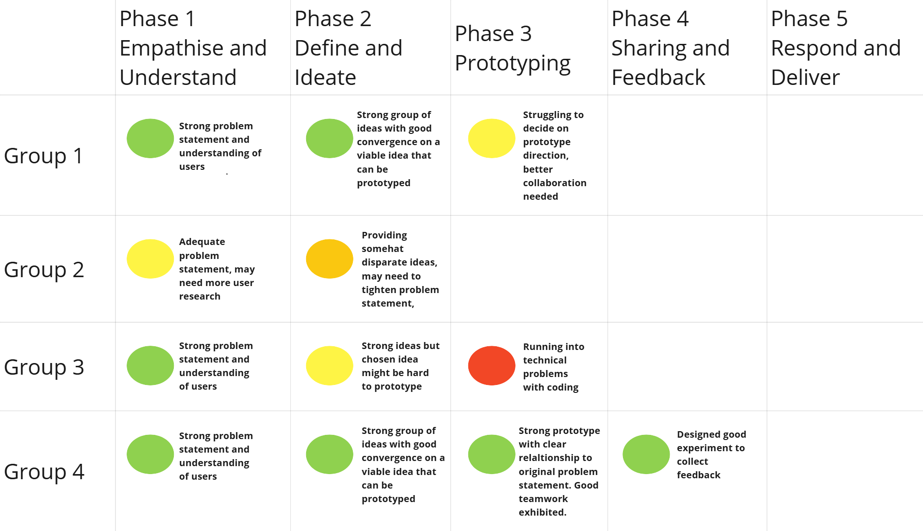

Teams can add their own insights to the board to describe what problems they encountered at each phase or what went well. A red might mean a complete stop until a problem is solved. A team could progress with a yellow or orange marker, but this might negatively affect their ability to complete the next stage (for example, non-converged problem statement will lead to disparate ideas, as is the case with Group 2 in the example above).

An online tool like Trello could also be used to implement the tracker digitally. However, it would create more buy-in and involvement to create this tracker as a physical wall-chart and display it in the classroom.

# Teacher Observation Log

An observation log is useful for teachers to record their own observations on student activity. These are anecdotal observations. Focus on:

* **Skill Application:** Highlight specific moments when a student demonstrated creativity, collaboration, or resilience.
* **Challenges Faced:** Note when students struggled and how they attempted to overcome these difficulties.
* **Growth Indicators:** Record improvements in skills such as problem-solving, communication, and adaptability.

|  |  |  |  |  |
| --- | --- | --- | --- | --- |
| **Day** | **Group/**  **Student** | **Skill Application** | **Challenges Faced** | **Growth Indicators** |
|  |  |  |  |  |
|  |  |  |  |  |
|  |  |  |  |  |

In terms of organisation and filtering, the log may be best implemented in a Google Sheet / Excel or similar software. Entries can then be ordered easily by group, student, date or other heading. Entries could also be summarised using GenAI to provide an insight report for individual groups or students. For example, copying and pasting all the ‘Challenges faced’ into ChatGPT and asking it to rank the biggest challenges faced and provide further insights.

# Rubric for Final Evaluation

Evaluate students’ overall performance across all stages using a simple rubric This rubric could be deployed during the final presentation of work. Again, the rubric can be co-created with the students if being used as a sharable evaluation. The table below provides a structural example. Labels could be numerical or linguistic/ 3-5 categories depending on context.

This evaluation could be used for individual or for groups. Students can conduct peer assessment of people in their own groups, or indeed self-assess.

|  |  |  |  |  |
| --- | --- | --- | --- | --- |
| **Success Criteria** | **1-**  **Improving** | **2-**  **Mastering** | **3-**  **Advanced** | **4-**  **Champion** |
| Depth of Empathy |  |  |  |  |
| Clarity of Problem in how it is defined |  |  |  |  |
| Creativity in Ideation |  |  |  |  |
| Quality of Prototype |  |  |  |  |
| Responsiveness to Feedback |  |  |  |  |
| Collaboration and Teamwork |  |  |  |  |

A more detailed rubric is shown below which provides descriptives criteria for each level and uses a more formal Design Thinking descriptive language. If using this rubric electronically, you can use coloured boxes to denote how far along each of the scales a student or group is.

|  |  |  |  |  |  |
| --- | --- | --- | --- | --- | --- |
| **Criteria** | **Collaboration** | **Creativity** | **Critical Thinking** | **Communication** | **Culminating Product** |
| Level 1 (Emerging) | Student works independently and does not contribute to the project as a team member | Student generates few original ideas and is hesitant to try new approaches to the problem | Student analyses the problem from their own perspective and struggles to use information and feedback to improve their solutions | Student does not communicate their ideas or the rationale behind their solutions to their team members or the audience | The culminating product is poorly designed, does not meet the needs of the end-users, and does not effectively solve the problem |
| Level 2 (Developing) | Student works together with others with some cooperation and contribution, but struggles to listen and build on other’s ideas | Student does not generate any original ideas and does not attempt to try new approaches to the problem | Student does not analyse the problem or use information and feedback to improve their solutions | Student struggles to communicate their ideas and the rationale behind their solutions to their team members and the audience | There is no culminating product |
| Level 3 (Proficient) | Student works together with others cooperatively, listening to and building on other’s ideas, and contributes to the project an equitable amount | Student generates multiple and innovative ideas and takes risks in trying out novel solutions to the problem | Student analyses the problem from multiple perspectives and effectively use information and feedback to refine their solutions | Student communicates their ideas and the rationale behind their solutions to their team members and the audience with some clarity and organization | The culminating product is well-designed, meets the needs of the end-users, and effectively solves the problem |
| Level 4 (Exemplary) | Student works together with others seamlessly, actively listening to and building on other’s ideas, and contributes significantly to the project | Student generates some original ideas and shows is willing to try new approaches to the problem | Student analyses the problem from a few perspectives and uses information and feedback to improve their solutions to some degree | Student effectively communicates their ideas and the rationale behind their solutions to their team members and the audience | The culminating product is designed adequately, meets most of the needs of the end-users, and solves the problem to some degree |