**Teaching Design Thinking with Digital Technologies**

**Open Learn Course**

**A brief introduction**

This online course *Teaching design thinking with digital technologies* is aimed at teachers or tutors at any level of education including primary, secondary, further and higher education. The course focuses on helping teachers understand what design thinking is and how it can be used with the support of complementary digital technologies, which can enable easy and effective implementation of design thinking in both a physical and an online setting.

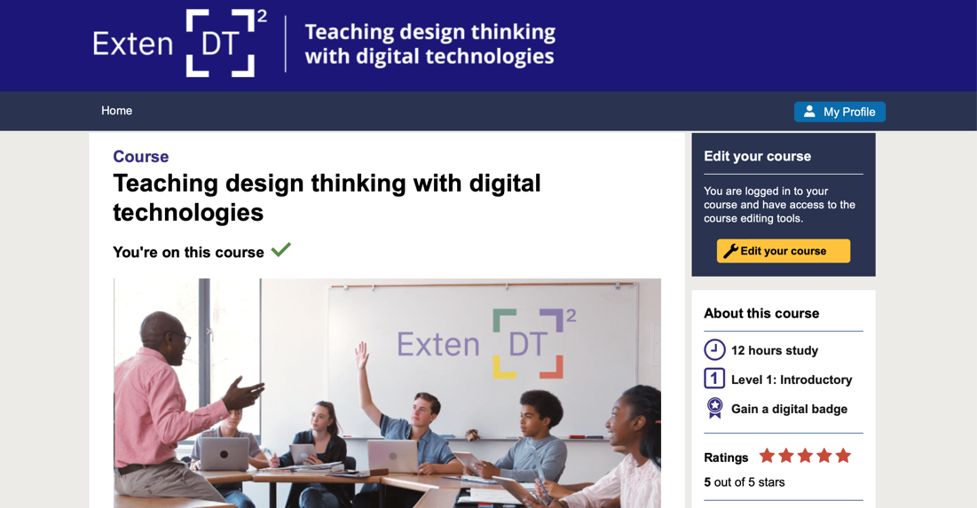

*Figure 1 A screenshot of the Open Learn Course*

**Course Learning objectives**:

* Explain to your students what design thinking is and why the Exten.(D.T.)² Digital Design Thinking Model can help provide solutions to challenges they face in school, work or life.
* Demonstrate the added value of using digital technologies for design thinking activities.
* Experiment with digital technologies and reflect on which ones to use in design thinking projects.
* Use design thinking projects to help students identify and solve real-world problems they find relevant and meaningful.
* Develop an activity plan you can implement with your students next time you teach.

This course has been designed by the project [Extending Design Thinking with Emerging Digital Technologies Exten.(D.T.)²](https://extendt2.eu/). The project has been co-funded by Horizon Europe and Innovate UK and involves partners from Sweden, UK, Greece, Norway, Belgium, and Ireland.

**Note:**The course activities are practical in nature and involve tasks such as downloading files to your desktop, creating a set of commands and manipulating different web applications to produce artefacts. These tasks may not be easily completed using a mobile device (such as a phone or tablet). Teachers are therefore encouraged to use a computer with a standard desktop operating system such as a PC or Mac (or laptop version of these) when engaging with the activities to enable a more accessible and user-friendly learning experience.

**Expected participants**: Primary, secondary, further and higher education teachers or tutors

**Course Link**: [www.open.edu/openlearncreate/ExtenDT2](https://eur01.safelinks.protection.outlook.com/?url=http%3A%2F%2Fwww.open.edu%2Fopenlearncreate%2FExtenDT2&data=05%7C02%7Csagun.shrestha%40open.ac.uk%7C7a86555106244092699608dcf83002e2%7C0e2ed45596af4100bed3a8e5fd981685%7C0%7C0%7C638658132359337061%7CUnknown%7CTWFpbGZsb3d8eyJWIjoiMC4wLjAwMDAiLCJQIjoiV2luMzIiLCJBTiI6Ik1haWwiLCJXVCI6Mn0%3D%7C0%7C%7C%7C&sdata=DFqokR762GrgGOt6AFOJAKZArul5nq7dlBQQzHoakp0%3D&reserved=0)

**Time required for course completion:** **12 hours**

**Duration to complete**: 01 November to 20 December

**What you will achieve upon completion:**

* A certificate of completion
* A digital badge
* Knowledge on and skills in integrating design thinking activity assisted by emerging technologies in pedagogy
* Knowledge on and skills in using some emerging technologies such as a survey tool, a tool to develop online games to tackle socio-scientific issues, create and print 3D models and design virtual robotics.

**Cost:** We offer this course at no cost.

**Assessment model:**

There is no formal assessment; however, to be eligible to earn a certificate of completion, you need to achieve a score of 80% or higher on an end quiz. The quiz comprises a set of questions that tests your knowledge and understanding on teaching design thinking with emerging digital technologies. Also, there are some inline reflective questions on the course that trigger you to reflect on the course materials.

**How to enrol:**

1. **Click on the course link** [www.open.edu/openlearncreate/ExtenDT2](https://eur01.safelinks.protection.outlook.com/?url=http%3A%2F%2Fwww.open.edu%2Fopenlearncreate%2FExtenDT2&data=05%7C02%7Csagun.shrestha%40open.ac.uk%7C7a86555106244092699608dcf83002e2%7C0e2ed45596af4100bed3a8e5fd981685%7C0%7C0%7C638658132359337061%7CUnknown%7CTWFpbGZsb3d8eyJWIjoiMC4wLjAwMDAiLCJQIjoiV2luMzIiLCJBTiI6Ik1haWwiLCJXVCI6Mn0%3D%7C0%7C%7C%7C&sdata=DFqokR762GrgGOt6AFOJAKZArul5nq7dlBQQzHoakp0%3D&reserved=0)
2. Click on 'Continue' as indicated below:

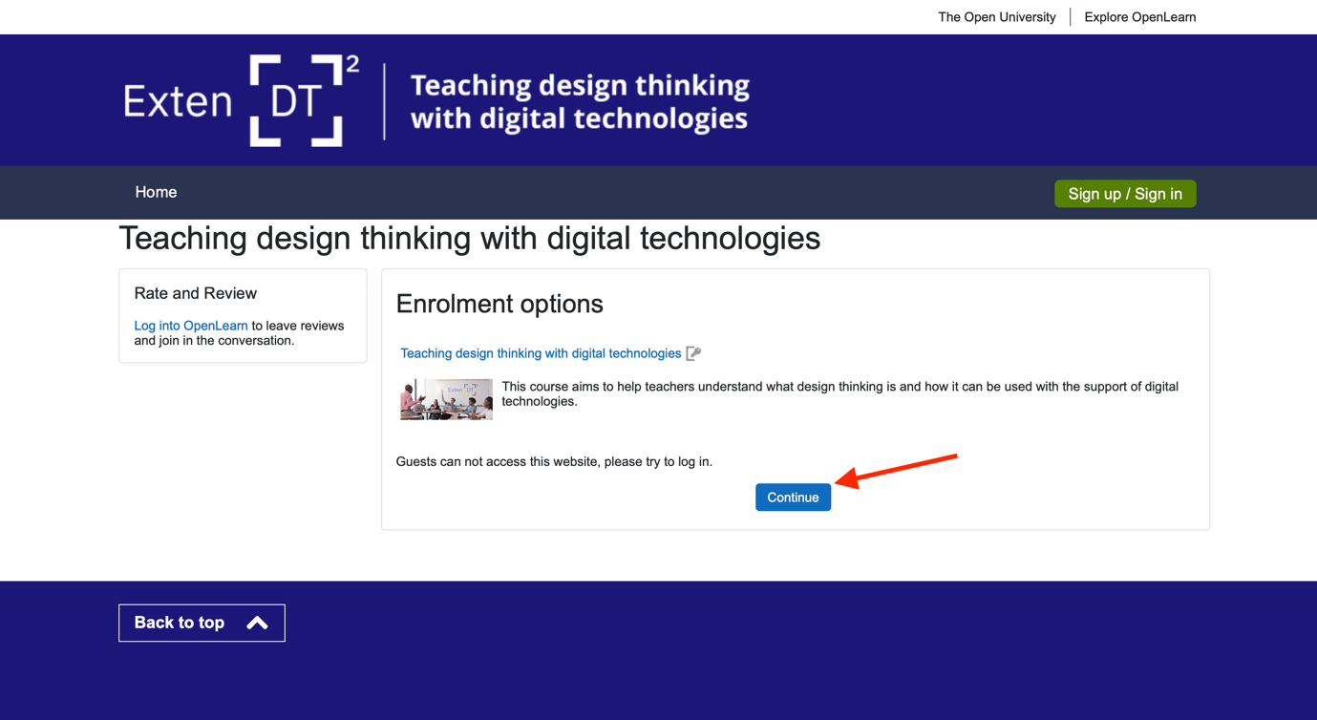

2. Click on create account as a new visitor.

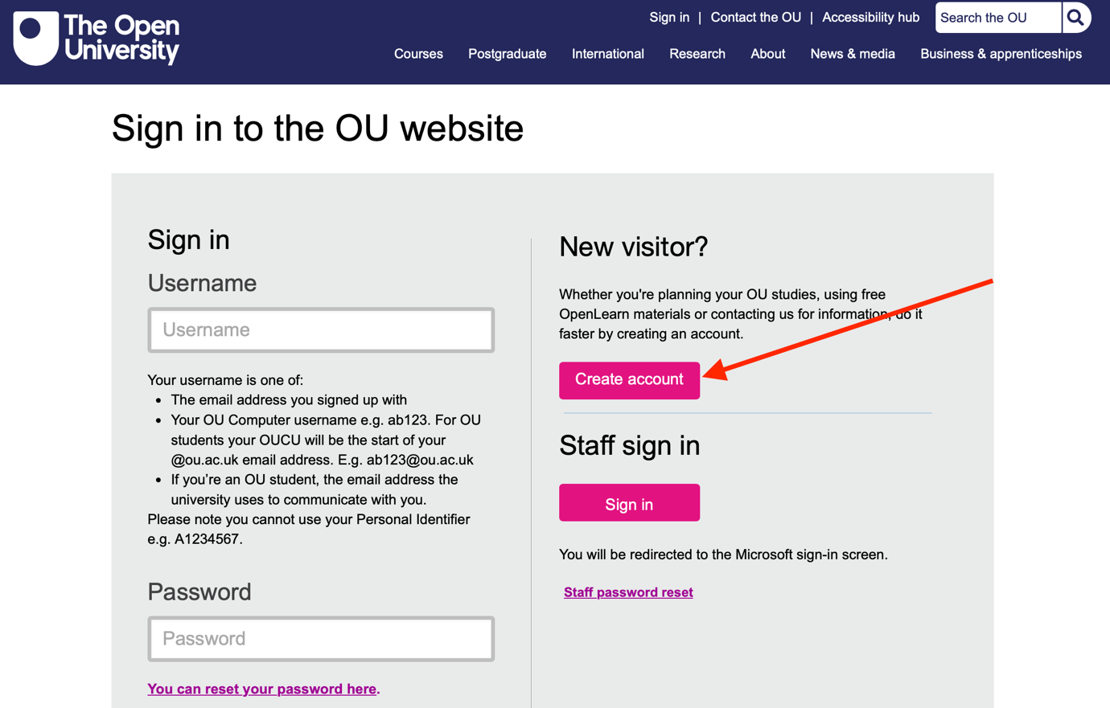

3. Fill in the form.

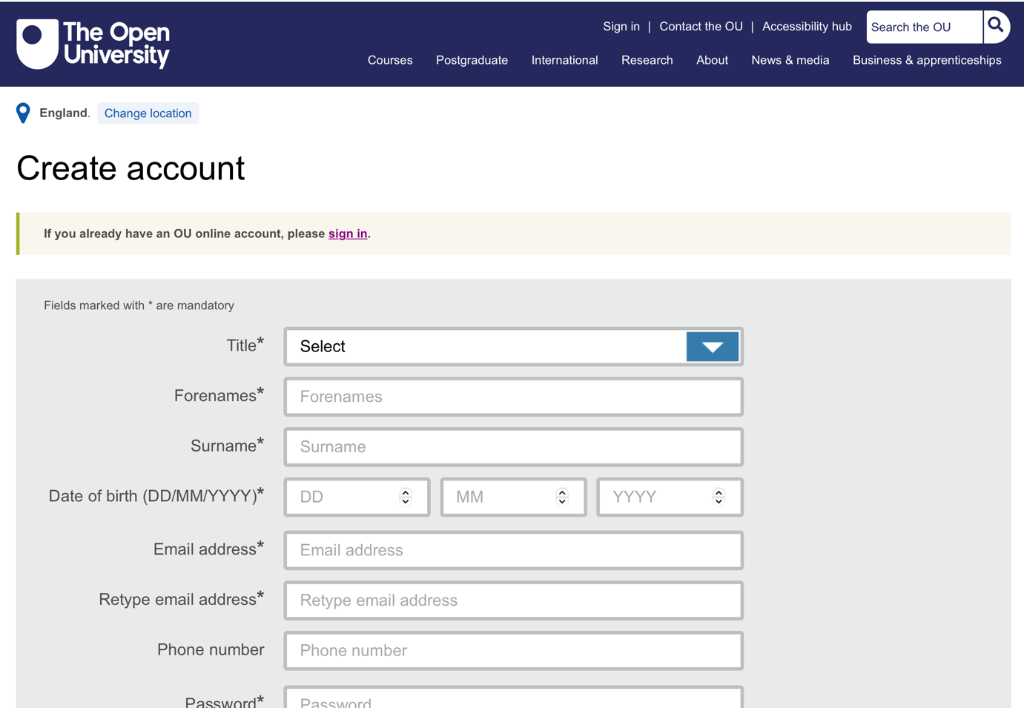

4. Submit the form

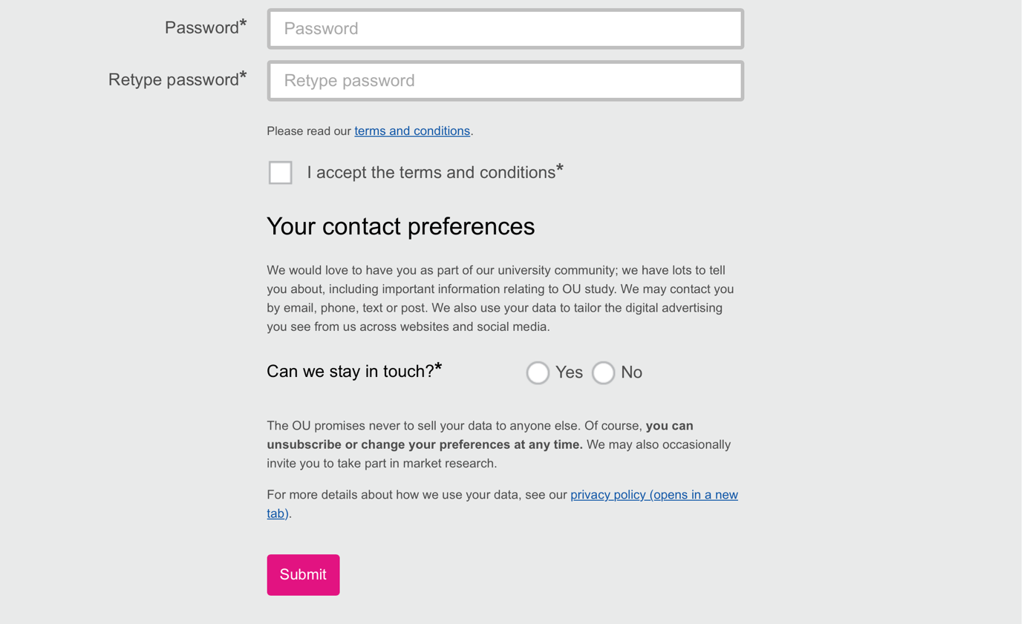

5. Sign in to the OU website using the username and passwords you used while filling in the form and click sign in. 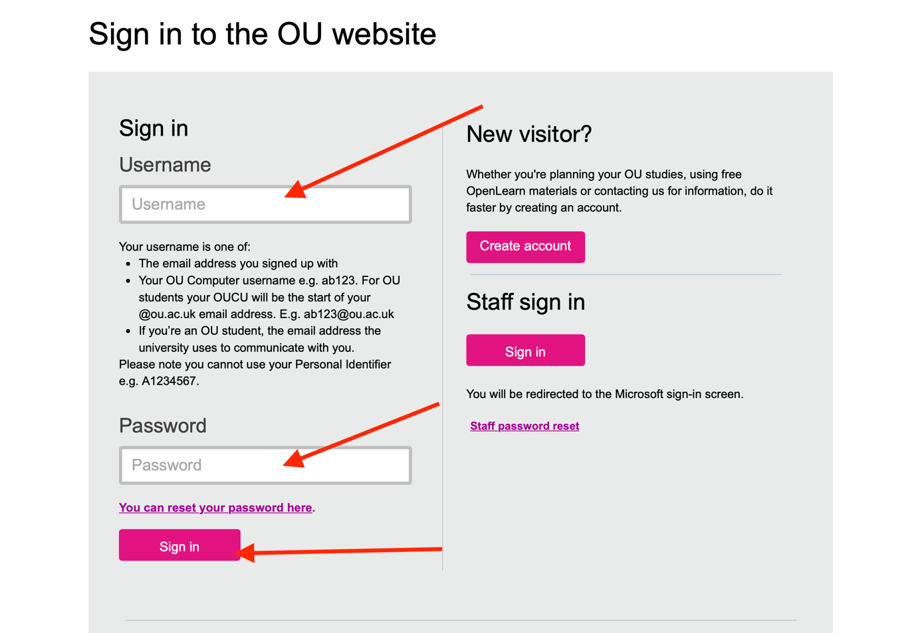

6. Click on the course link again: [www.open.edu/openlearncreate/ExtenDT2](https://eur01.safelinks.protection.outlook.com/?url=http%3A%2F%2Fwww.open.edu%2Fopenlearncreate%2FExtenDT2&data=05%7C02%7Csagun.shrestha%40open.ac.uk%7C7a86555106244092699608dcf83002e2%7C0e2ed45596af4100bed3a8e5fd981685%7C0%7C0%7C638658132359337061%7CUnknown%7CTWFpbGZsb3d8eyJWIjoiMC4wLjAwMDAiLCJQIjoiV2luMzIiLCJBTiI6Ik1haWwiLCJXVCI6Mn0%3D%7C0%7C%7C%7C&sdata=DFqokR762GrgGOt6AFOJAKZArul5nq7dlBQQzHoakp0%3D&reserved=0) , if you are not prompted to insert the enrolment key, type enrolment key '**Exten(DT)2-pilot** ' and press enrol me. If you don't see enrol me option. Click on continue sign in using your user name and password one more time, insert the enrolment key **Exten(DT)2-pilot** and press enrol me.

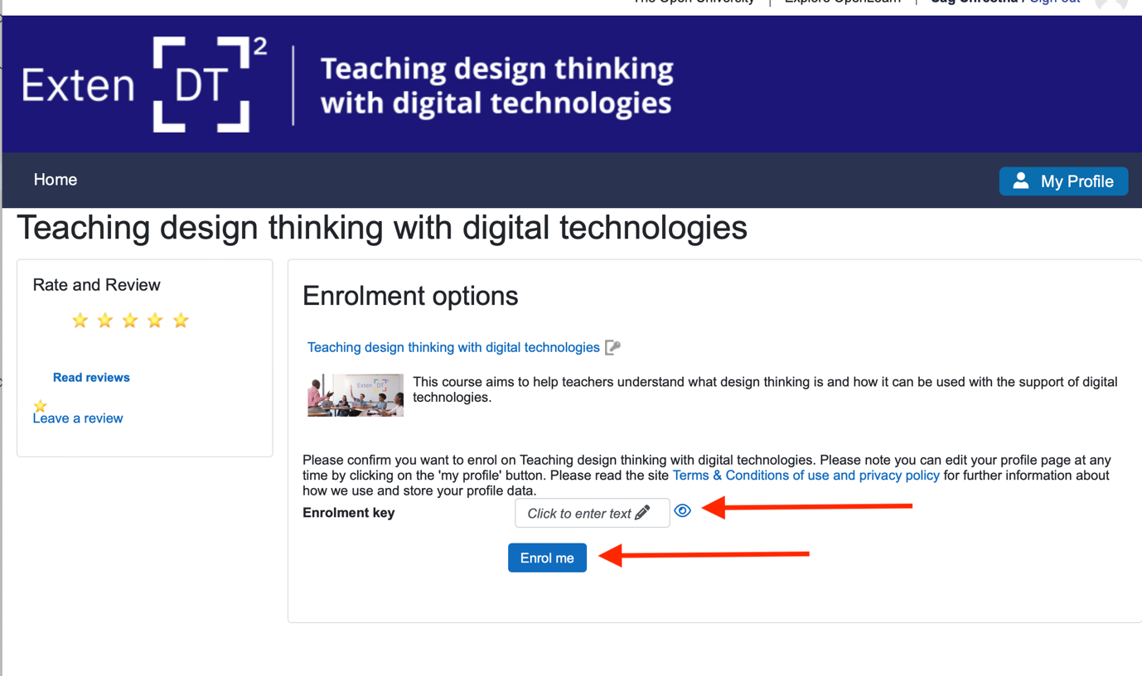

Now you are ready to go through course materials.

**Should you have any further questions about the course or project, please contact at extendt2@gmail.com.**