Exten(DT)² Project meeting
17-18th April 2024

Milton Keynes campus
When you arrive, a campus map (pdf 680kb) is available for you to get around the campus.
Historical OU Campus Tour
This virtual tour will take you around The Open University campus, pointing out all of the main buildings and revealing the people behind the names given to the many buildings - Wilson, Jennie Lee, Christodoulou, Gardiner, Crowther and Briggs to name but a few.
Open Research Online
Our research repository ORO has recorded more than 2.2 million downloads since 2006. Around 26,000 research articles are publicly available, part of our commitment to open access to educational resources.
OU art collection
The Open University campus has a large collection of artwork from around the world, for example Modern Misses by Zimbabwean sculptor Dominic Benhura.

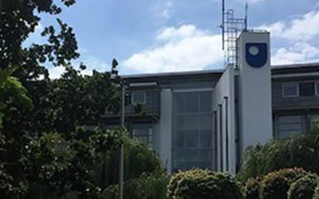
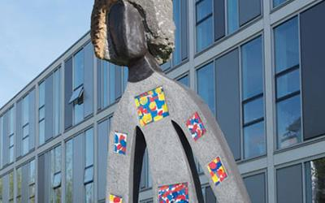

Getting to Walton Hall
The Open University has its headquarters at Walton Hall in Milton Keynes, which is 80km north of Central London, midway between Oxford and Cambridge, and just off the M1 motorway, linking it to Birmingham and the north of England.
If you’re coming by car, our address is:
The Open University
Walton Hall
Milton Keynes
MK7 6AA

The campus is 4 miles from Milton Keynes Central railway station, served by the West Coast Main Line between Birmingham and London (Euston).
Bus Services
Service | Operator | Route and link to service information |  | Service update
F77 / F70 | Arriva | The OU - Bletchley - Leighton Buzzard - Dunstable – Luton  For further information please visit  https://www.arrivabus.co.uk/help/coronavirus/coronavirus-timetable-information
MK Connect |  | Please follow this link for information on MK Connect
X4 | Arriva | Please follow this link for a timetable Download Local Bus Timetables | Arriva Bus
On weekdays the buses stop at our Campus bus stops on St. Michael’s Drive; please visit the Campus Map On weekday evenings and at weekends you need to catch the bus at the stop on Brickhill Street V10.

More information on bus timetables, maps and travel updates please visit Milton Keynes Council Highways and Transport Hub/bus and taxi/bus timetables maps and travel updates website

Taxis- Milton Keynes
The Open University use the services of the following taxi companies;
- Skyline Taxis : +44(0)1908 222111 (University preferred supplier)
- ASL Taxis: +44(0)7836 676055
- Uber

Hotels in Milton Keynes near the OU, Walton Hall, Kents Hill, Milton Keynes MK7 6AA
Kents Hill Park  Walking distance of OU | Swallow House, Timbold Dr, Kents Hill, Milton Keynes MK7 6BZ  0044 1908 358000
Delta Hotel  Walking distance of OU | Kents Hill Park, Timbold Dr, Kents Hill, Milton Keynes MK7 6HL  0044 1908 694433
Premier Inn at Willen Lake  Next to Willen Lake | V10 Brickhill St, Willen, Milton Keynes MK15 0DS  0044 333 003 8101
Premier Inn Milton Keynes South  Next to Caldecotte Lake | The Caldecotte Pub and Grill, Lakeside Grove, Milton Keynes MK7 8HP  0044 333 321 1334

Hotels Near UCL Knowledge Lab, 23-29 Emerald St, London WC1N 3QS

Premier Inn London Holborn hotel | 27-29 Red Lion St, London WC1R 4PS  0044 333 321 9346
Thistle London Bloomsbury Park | 126 Southampton Row, London WC1B 5AD  0044 20 7523 5051
President Hotel | 56-60 Guilford St, Russell Sq, London WC1N 1DB  0044 20 7837 8844
Bedford Hotel | 83- 95 Southampton Row, London WC1B 4HD  44 20 7636 7822

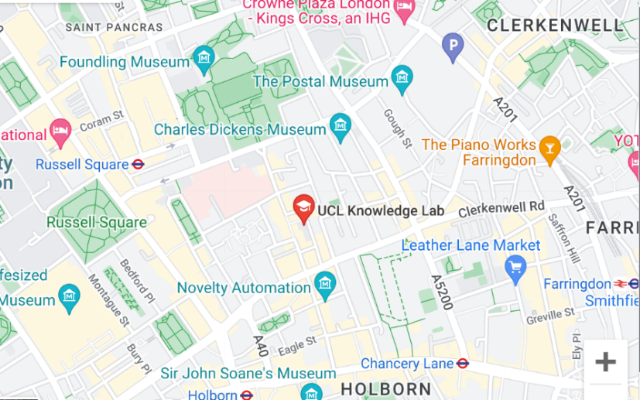

Travel in and around London
Transport for London – A website that combines all travel around London. Planning your journey, maps, Up-to-date Times, Faults and how to pay. All underground and buses now take contactless debit cards as payment on each barrier. There is daily cap of £8.10 for Zones 1 & 2. There might be a higher cap for peak-times.
Uber
Travel from London to Milton Keynes
Travelling by train from London Euston Station is the best way. You can either get a train to Bletchley or Milton Keynes Central. Depending on the train company and the time of day, trains can take between 30 mins and 107 mins. A return ticket is cheaper than buying 2 singles.
Thetrainline.com

If you need any further assistance with making arrangements, please email Hannah.Clarkson@open.ac.uk

